Family Concert Series September 16 & 4pm
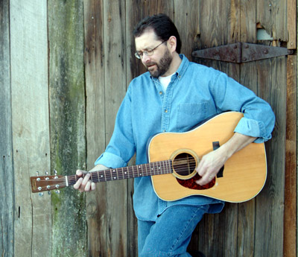
FENCE Center

Tom Fisch grew up in Albany, NY, and won his first guitar in a raffle at a school bazaar when he was ten years old and went on to entertain audiences for many years throughout the Northeast.
In 1991, Tom moved to Nashville, TN to further his songwriting career. He formed his own publishing company and his songs have been recorded by a number of artists, including the Oak Ridge Boys and Swiss country singer Erica Arnold. Tom continues to pitch his songs to other artists but his main focus now lies in his own career as a performer. In 2004, Tom relocated to Western North Carolina and it’s thriving acoustic music scene. With the backdrop of the Blue Ridge Mountains for inspiration, Tom and his music have found a comfortable place to call home. And wherever he performs, audiences continue to connect with the warm, appealling style, diverse range of material, and talent this seasoned performer brings to the stage. " www.tomfisch.com
Please join us for a wonderful afternoon with Tom Fisch and refreshments to follow. This free family concert series is made possible by the Kirby Foundation at Polk County Community Foundation.

